**CPSC 2211 Human-Computer Interaction Educational Tools for the future**

Student: Tomas Gonzalez Ortega ID: 100266942. Langara College 2018

**Introduction**

Technology has spread widely during the last years, from personal computers to tablets, mobile devices to smart phones, everything seems possible. During the International Conference of the Learning Sciences hosted on 2012, Pierre Dillenbourg addressed that many problems in education are not primarily solved innovating in learning theory but with creative design (particularly in Human-Computer Interaction). Recent research has been focused on making technology and training as much interactive as possible, indicating that when users are properly challenged, involved and motivated their learning experience outcome has a better curve than when they are not. For instance, how many students have used Lynda.com, Web Assign or any other online educational tool during their educational process here at Langara? All the feedback gathered after years of implementation might prove to be golden for the nursing the right track for those tools to survive in time and actually have long term effects.

It is important to understand that HCI is not focus on the design of easy-access menus and interactive screens but to build, design and implement responsive human-centred computer systems. In education this translates into creating a memorable tutoring experiences encouraging long lasting enhanced learning. In fact, HCI provides a series of interesting theories about attention, knowledge, memory and perception when it comes to the process of access, store and retrieve all the knowledge gained through experience.

I strongly believe having a smart accessible design would minimize the educational gap among the world since it will minimize the expenses in actual distribution of the material and facilitate the accessibility of it. For that we will analyze the educational models in contemporary society, the actual tools, how they work and how they are regulated.

**Society & Online Learning**

**Social constructivism and Connectivism**: An approach to the ways society understands active learning and online teaching. In education is transcendental understanding that a society is always evolving into something new. These nomadic manoeuvres are enticed to social tendencies, political models, updates in technology, etc. According to *The learning society* (by Halkett, R., Schneider P., & Horne, M.) these are “founded on the acquisition, renewal and use of knowledge”. Recently the focal point was reconceptualised on learning, learners and their experiences. Since society provides easy access to information due to the technological advances, we have to create a distinction between acquiring knowledge and acquiring data, thus the relevance of knowing a fact is becoming shadowed with the power of accessing, analyzing and using it. For years HCI has been involved with accessibility and techniques to design smart interactives systems for a broad brand of users. Many technologies we use in our daily life, will eventually be updated into funnier and dynamic systems, in education this will translate into engaging successfully with their own learning. HCI grabs the way humans gather, store and use data and how they work to perform the same with new information. This extends to the way students operate. The learning process society use in the Western world is an active method based on social constructionism, particularly to “constructive alignment” (Biggs 1996). According to the author, the instructor’s role is not transmitting the right understanding but helping students to create their own under certain criteria. In relation to this Geoff Petty, one of the leading experts in teaching methods in UK described this approach as learning by doing: “Research shows that active learning is much better recalled, enjoyed and understood. Active methods require us to ‘make our own meaning’, that is, develop our own conceptualizations of what we are learning” (2004, p.239). What it makes this approach stronger than passive methods like listening, is the actual physical paths created in our brain during synapse.

Since the HCI maxim is accessibility one of the main tools it disposes is Online Learning. Two pedagogies highly influential in this field are social constructivism and Connectivism. The first puts an emphasis on the social axis of the learning process: discussion, collaboration for ideas to be constructed from experience so they can have meaning through an active learning. The next methodology is mainly concerned on our associations, how a network of ideas can create bigger knowledge. All this, point the concept of knowing where to find information is actually more relevant than the data itself. This becomes crucial on an era in which Internet can connect millions of people and interchange and store data in between.

**Changes in learning due to technology**: In the last 20 years significant changes has been made in our daily lives due to technology. Personal computers, tablets, smart phones and the Internet is just to mention some of them. All these technologies have become so embedded in society that have changed several layers we understand the world. With the arrival of the Web 2.0 a lot of social changes were made, particularly in the way we aboard education. All these modifications have presented challenges in how to update the educational methods. As we mentioned before in *The Learning Society* (by Halkett, R., Schneider P., & Horne, M.) it was suggested that using video and the mobility of the net people can combine work and share knowledge around the globe everywhere internet is accessible. This Cisco report also remarks the following important developments in learning through the last years:

* Learning is a completely active social procedure. Everything learned is absorbed through interaction between peers, instructors and others.
* Learning is critically affected by the levels of motivation: This goes both ways depending on the positive or negative disposition the learner might present towards the topic presented.
* Learning start at different stages for each learner and they usually take different ways.
* Learning effectively evolves previous knowledge, engaging it progressively, forcing it to create new conceptions. It is highly important, that tutors be focused into monitoring this progress to successfully assess it.

**Montessori and technology enhanced learning:** When we talk about enhanced learning technology we find several perceptions in society. In 2010 JISC defined it as a method in where a big scope of learners is provided with strong technological tools intensifying the learning experience. Another vision was provided by Goodyear and Retails in the same year using the term to describe all instances (hardware & software) in which technology augments the learning routine whereas it makes it more effective, efficient or pleasant. Some of the artifacts described in the article were interactive whiteboards, smart tables, collaborative learning systems embedded in computers, simulators, online repositories of learning content and data, educational games, social Apps and virtual reality.

Despite the Montessori educational philosophy was develop in the early 20th century it was not until 1960s until it became widely accepted, due to more accessibility of the materials and personnel involved in this methodology. Developed by Maria Montessori her approach encourages learning through experimentation and independent thinking leaving the classical textbook curriculum behind. Despite have been successfully tested at the beginning of the century it was extremely costly for schools and in the end impracticable in terms of materials, the number of assistants needed to carry up the evaluation and further tutoring.

On *Technology enhanced learning: The good, the bad, and the ugly* (Dror, 2008) it is described how training, independent it is traditional, e-learning or blended is strongly linked to connections and dependencies on the cognitive system. Research made on this area has found that properly-cognitively challenged, engaged and involved users have developed a better understanding from the learning experience, hence technology efficiency in education becomes more effective by making it more interactive. The real challenge consists into how to create abstract models that can be long lasting and enable development into the individuals, something reached by the creation of memorable learning experiences leaving a physical impression on the brain. On *The role of cognitive theory in human–computer interface* (Chalmers, 2003) it is described a process of association using questions like ‘Where am I?’, ‘Where was I?’ or ‘Where am I going?’ in which information presented on a computer screen is connected to the ‘big picture’.

**Design**

Before jumping into the actual tools, it is very important to understand what design is and what is considered good or poor design. We mentioned before that we use a lot of interactive technology on a daily basis, but think for a while are some of them more or less frustrating than others? While some systems are user friendly others are cryptic and bizarre. One of the aim of interaction design is reducing the negative aspects (annoyance, frustration) of the experience while empowering the positive ones (engagement, enjoyment, etc), so basically, developing products that are usable: straightforward, effective and fun.

We will analyze a couple of examples to understand good and bad design, consider the presented scenarios:

You are staying at an hotel, for a couple of days on a business trip. You realize you left your mobile at home, so you only rely on the hotel’s voice mail system. When a message comes in you try to follow the instructions:

* Touch 41. The system explains “You have reached the Marriot Hotel at Richmond voice message centre. Please kindly enter the suite number for which you would like to leave a message”. You wait to see is there any directions about how to do that just to find there isn’t any further instructions.
* Touch *, your room number, and #. The system replies: You have reached the mailbox for room 106, type in your password to leave a message”. After you do so you hear the system reply: “Please enter the room number again then your password”. At this point you have no idea about your password or the actual room number despite you supposedly knew which it was. So, you call the front desk clerk for help: the worker kindly explains that involves entering the room number and the extension number of the phone. On top of it is explained to you it actually takes 6 steps to reach your messages and 5 to leave a message.

All those features allow a user to consider this voice mail system is infuriating, confusing, inefficient, challenging, offers no documentation nor feedback violating several of the Usability Heuristics (Nielsen, 1995) offering a perfect example of bad design.

On the other hand, you are introduced the marble answering machine:

Incoming messages are represented using physical marbles. The number of marbles piled into the end right corner is the exact number of messages you have. Every time you drop one of the marbles into a slot machine the recorded message is played. Dropping the same marble into another slot actually dials back to who left the message. This system allows the *Adapted from Gillian Crampton Smith: “The hand that Rocks the Cradle” ID Megazine, May/June 1995, pp 6—65.*

user a more user-friendly mechanism to perform the same operation, relating it to immediate feedback of how many messages the user has, presenting an aesthetically elegant and easy to use format, minimizes the steps of interaction, minimal design and minimal functionality. This answering machine was designed by Durrell Bishop at the Royal College of Art in London. More information on <https://vimeo.com/19930744>

**So, what to design?** This whole process involves considering who is going to use the products, how are they going to be used and what kind of activities people are doing while interacting with them, when and where are they going to be used. When deciding which choices to make we may consider: Taking in consideration what people are good or bad at and what might help them become better at certain operations to include it in your design, think into the steps to provide a quality experience, listening the testing feedback and modify the designer’s model, test time & again evolving the system. After considering those examples and suggestions we can define interactive design as: conceiving products to enhance the ways communities interact in their everyday activities. This umbrella term covers a broad amount of designing processes: experience design, interactive systems, product design, software design, user interface design user-centered design and web design; all these disciplines, fields and approaches and even more have a strong connection through interaction Design. The following diagram tries 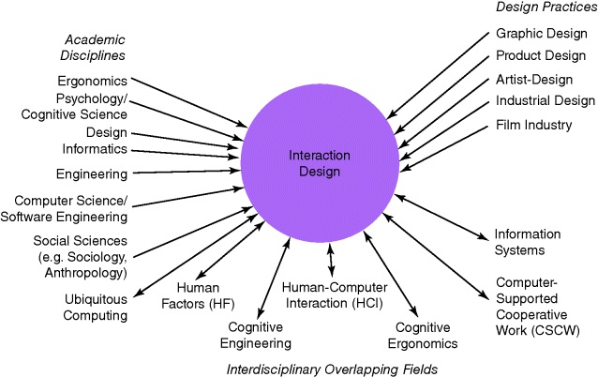to display to relationship among academic disciplines, design practices and interdisciplinary fields concerned to the topic: (and how these overlap, represented by double arrowed lines)

*Interdisciplinary Overlapping Fields, diagram from Interaction Design, Beyond Human-Computer Interaction, 4th Edition, May 2015, pp 22.*

All these disciplines reach at a certain point the same destination, the User Experience field. Often called UX, is described as “all aspect of the end-user’s interaction with the company, its services and its products (Nielsen and Normal, 2014). Of central importance aesthetics, content, functionality and usability but not limited to these concepts, elements like how fun, how healthy, how social, how culturally rich, how diverse and inclusive these systems/items are (Carroll, 2004). On *Technology as Experience framework* (McCarthy and Wright, 2004) UX is considered in terms of how these systems or items are felt by users, proposing 4 core threads:

* The compositional thread: Related to the narrative part of the experience. Involves the internal thinking made by the users while operating the system.
* The emotional thread: Related to the emotional response experience while operating the system. Emotions lead to judgment, hence help defining a product as good or bad.
* The spatio-temporal thread: Relating the sense of space and time in which the experience occurs. Whenever we talk about standing still, speed up, slowing down while describing space in terms of public space and needing one’s personal space.
* The sensual thread: Relating the sensorial connection between users and the system while operating the system, particularly with immersive products which might involve comfort, fear, joy, pain, thrill among others.

These threads are intended to help designers in the creation process from the very conception to the whole team-users interaction making easy to relate technology with the actual experience simulation and testing. The more the designer understands about the context in which the user live and work the better. Having considered all the previous aspects, we might say interaction design involves the following:

* Identifying requirements involved in the project.
* Presenting options as a feasible alternatives.
* Prototyping based on the most promising options.
* Evaluating – Testing.

The process goes on and on in a repeating spiral who contemplates several testing processes until the products are addressed in all the elements previously described. Developing effectiveness, efficiency, safety, utility, learnability and memorability, all wrapped under a concept known as Usability Goals in the HCI world. These goals lead to the actual user experience goals. Among the desirable aspects we found: Satisfying, helpful, fun, provocative, motivating, enjoyable, engaging, challenging, surprising, pleasurable, socially enhancing, rewarding, exiting, creational, fulfilling, entertaining and cognitively stimulating.

**Design Principles:** these are generalized abstractions intended to guide designers through the whole process, from the thinking to the actual development and testing. These are derived from experience, theory-based knowledge and of course, common sense, offering the dos and don’ts of interaction design. These are the most common ones:

* Affordance: Refers to an object’s attribute that allows the users how to use it. It means to give a clue (Norman, 2002). The same author extends affordance suggesting there are 2 kinds of affordance: perceived and real, based on if they are virtual (screen based) or an actual physical object. The difference between these conceptions allow designers focus on elements like physical controls for the real ones or learned conventions for the case of the virtual ones.
* Consistency: Refers to the similarity between interfaces and the real-world operations. These link makes them easier to learn and use.
* Constraints: Refers to restrict the amount of interactions a user can perform on an instance. A typical example of this is to deactivate certain menu options on graphical interfaces shading them in gray, depending on the software instance.
* Feedback: Refers to the information that is sent back once an action is performed allowing the users to understand where they stand and continue their work based on this data. These can come as audio, tactile, verbal, visual and combinations of these.

Once you start applying these fundamentals trade-off problems will start to arise, for example constraints diminish visibility. The more consistent the interface is with the real world may tend to increase its usage difficulty. So, it is up to the designer to balance all these situations and avoid conundrums.

**Tools**

**Interfaces**: In education we find a vast number of systems, from web pages to games most of them requiring an intricate user design development. E-learning for example requires a tremendous focus on the interface, which can be the difference between great learning and not learning at all. On 2009 Virginia Commonwealth University published a paper on Online Teaching and Learning, which remarked the social changes and implications due to technology on the growing field of Online teaching and learning and how this might be carefully examined to align it to the educational standards. On the research *Seven principles for good practice in undergraduate education* (Chickering & Gamson, 1987) there were presented 7 principles viewed as determinant to effective learning. These can be synthetized as the following:

* Communicating high expectations.
* Facilitating contact methods between the faculty and the students.
* Emphasizing timings.
* Encouraging cooperation amongst.
* Offering as much feedback as possible.
* Promoting active learning.
* Respecting diversity and how this will lead to different ways of learning.

The paper also describes a number of possible scenarios using these principles. Amongst them the most emblematic example is the Myers-Briggs Personality Inventory that allows the user the allocation of teams, podcasts, screencasts, wikis and youTube.

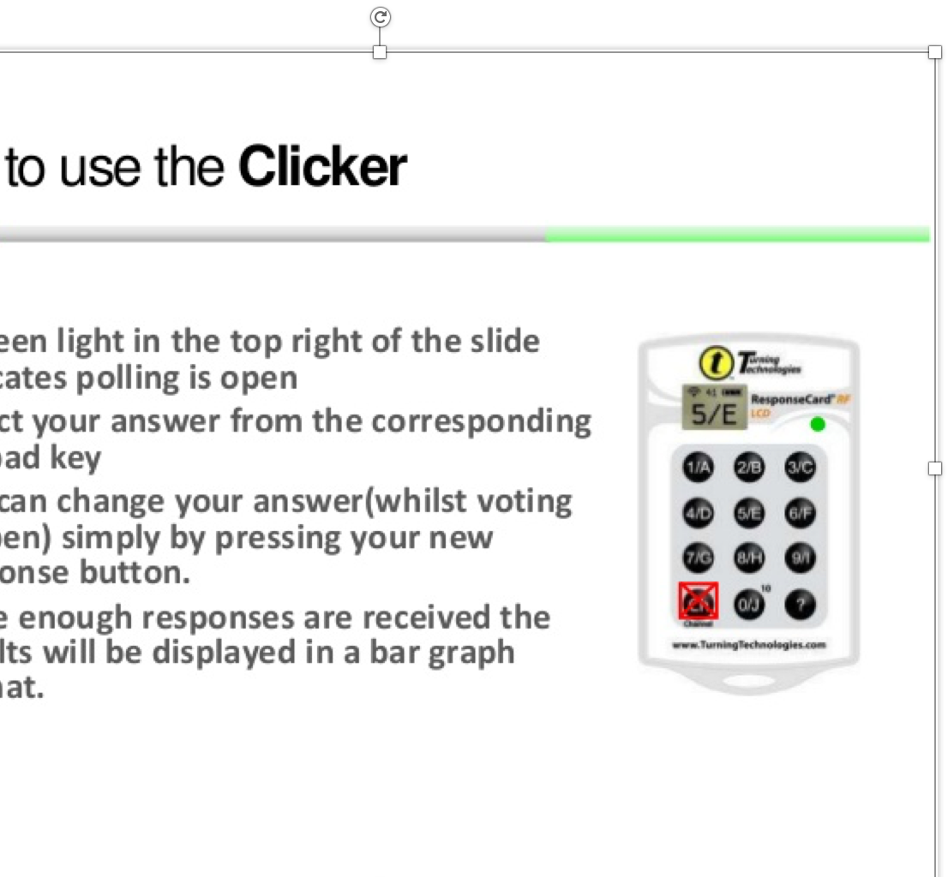

During the recent years one of the most used tools in education are Clickers. Small handed-held devices that allow users to answer questions by pressing button just like in “Who wants to be a Millionaire” TV show.

*University of Pretoria introduction and demonstration*

Several researches have been done using these devices. One of them described on *Teaching with classroom response systems: Creating active learning environments* (Bruff, 2009) found that Clickers were less effective if merely used for evaluation and tracking. Nevertheless, they were of a tremendous benefit used amongst small groups discussions augmenting the level of interaction of the class making it more dynamic and fun. Other research focused at quality of class interaction and cognitive processing, the results presented in *Clickers: A new teaching aid with exceptional promise* (Duncan, 2007) gave more lights on how interfaces and tools can enhance learning. Other topics presented in the paper was student satisfaction and teamwork. All key elements to create solid learning experiences has we have covered earlier in this research paper.

**Memory enhancement techniques:** One of the benefits discovered after years of investigation on education using these new techniques was that one may enhance memory using the right approach. Let’s review an example from the University of the West of Scotland made in 2013: Students are asked to participate supplying 10 items from their belongings. These are later visualised interacting with objects linked using numbers from 1 to 10. One links with a bun (any kind of it, a burger, a bagel, etc), two links with a shoe, three with a tree, four with a door, five with a hive, six with sticks and more associations. Students then visualise one of the objects they supplied with one of these recently described items. Some unforgettable examples emerged: lip gloss interacting with eight, which was designed as a gate; the student pictured a cow looking over the main gate with sticky glossy lips, definitely a memorable image. And some more funny, weird and even disturbing associations. Ten weeks later the class was asked if they could remember all ten random items. The experiment was a success, showing up that working in groups through discussion, all the students were able to recollect the details of these items.

This method shows that an idea can be simplified with a single image. Studies in Human memory show that most people have better recollection on images rather than verbal or written information, since they are concrete while raw data is abstract. The goal of this technique is presenting large amounts of data on an easy and understandable way. Visualisation applies directly to online learning, assisting in the learning experience providing memory aid. This along other techniques such as mnemonics or computer systems and workstations makes visual associations a user-friendly tool to enhance user’s memory.

**Learning through gaming:** Computer games are one of the most successful application domains in the whole interactive systems era, enormously popular. Even if they have been separated from most of the paradigms for designing usable interactive software. It is now clear that this less constrained environment has allowed much more freedom at the very moment to design, letting designers create highly usable interfaces mostly focused on user performance, user satisfaction and novelty over consistency. From small widgets to learn languages to super immersive worlds with vast content to explore. These immersive models have ignored windowing systems, standard widget libraries and the toolkits that usually define the look and feel of most conventional systems, it is all about innovation. There are many examples of this including gestural commands in Black and White, radar views in Warcraft, radial menus in Neverwinter Nights, Speed-coupled flying in Grand Theft Auto, transparent overlays in Diablo II, transparent menus in Everquest amongst others. In the early 80s HCI researchers considered games: Tom Malone looked into the genesis of the games’ compelling attribute and how to apply these to other applications; almost 40 years have passed, and games have changed tremendously. They can be categorized in many ways, we will center on the top 4:

* effortless community: Games create a user-friendly platform for people to create, join and participate in communities. Concepts like party (temporal group who share a mission, experience, loot or any other benefit provided by the game instance), clans (affiliation of people that share some sort of common goal), guilds (similar than the previous), alliances (usually designed as a group of clans, like in the Lineage 2 model, to achieve greater events or goals, like the defense of a castle siege which involves thousands of players)
* learning by watching: Games allow learning through mimic what most experienced users perform. Lately this has become widely popular through platforms like Twitch, which allow users to watch how others play or interact with an application. The content is broad and very diverse depending on communities’ interests, while in the States the main Twitch are intended to show Shooter games or makeup tutorials in South Korea one of the most popular streaming following this pattern is share lunch of dinner with a community, yes! A person presents the food and eats while the rest watch.
* deep customizability: Most immersive games allow users modifying and customize their user interface, often known only as UI. On some case those specifications are exportable in a file to share with the rest. This leads to Add-ons which are extensions to modify or increase the features and possibilities on the default options available on the UI.
* fluid system-human interaction: Games communicate data to users in non-disruptive ways allowing a more natural, immersive flow.

Even when games are seeing “just for kids” several successful interfaces have features that are completely applicable for an everyday situation with regular software.

Let’s review the results from *Learning from Games: HCI Design Innovations in Entertainment Software* (Brown, B., Dyck, J., Gutwin, C., Pinelle, D.). The games explored, and the data retrieved were gathered by this team using the following methodology:

* Each game was played individually, then as a group.
* Each game was analyzed in focus groups, cataloguing interaction techniques, UI and design.
* Each game watching session were performed, to explore the way other players not presented in the focus groups interacted. This included online streaming.
* For every game reviews and opinions presented on forums were collected.

This allowed the creation of the following table showing the games involved in the study, a selection decided not only on being successful in the market but with customers and critics.

|  |  |  |
| --- | --- | --- |
| Game | Genre | Mode |
| Warcraft III | Strategy | S, M |
| Ghost Recon | 1st-person shooter, strategy | S, M |
| Rogue Spear | 1st-person shooter, strategy | S, M |
| Half-Life | 1st-person shooter | S, M |
| FIFA World Cup | Sports | S, M |
| Medal of Honor | 1st-person shooter | S, M |
| EverQuest | Role playing | M |
| Diablo II | Action, role playing | S, M |
| The Sims | Simulation, strategy | S |
| Neverwinter Nights | Role playing | S, M |
| Comanche 4 | Simulation | S, M |
| MechWarrior 4 | Action, strategy | S, M |
| Grand Theft Auto | Action | S |
| Black and White | Strategy | S, M |

*Table 1. Games studied on Learning from Games: HCI Design Innovations in Entertainment Software (Brown, B., Dyck, J., Gutwin, C., Pinelle, D.) S stands for Single player and M stands for Multiplayer.*

Effortless community: Games involving great communities can make it easy to participate and interact. Several contents of the game can only be achieved while performed in big groups. These interactions require a critical mass of users, which can be trivial on mass multiplayer games, since just by connecting users will be linked to a vast multiplayer universe. Even though conventional Apps come from a single user mindset, using these techniques can help designers to create a more natural community of users, involving discussions enabling constant feedback and troubleshooting suggestions.

* Since forums, despite having a huge amount of threads (for example in the early 2000s Photoshop forums have more than 140,000 threads on their servers) and a constant flow of data interchange, are not exactly designed to fully take advantage of engaging other users in a regular way a lot of this communication potential is wasted, and communities require 3rd party systems to be fully integrated. Games allow users to make it very easy to connect to the online community and they make it easy to locate collaborators to form groups, using as previously mentioned parties, clans, guilds, alliances but more:
* Location: a spatio-temporal context which englobe users in an area.
* Conversation channels: games have different typical channels, usually labeled as “general”, “trade”, “ranked” and more, all to focus and filter topics of conversation making easier to engage in the subjects that matters to users in the moment.
* Friend lists: Working like a Contact list on your mobile it allows easy access to deploy personal messages and put users in contact with their favorite users.
* Visual identity: The creation of elements like “avatars” help users to identify themselves with a faction, an alignment and in the end with a community.

Learning by watching: We already mentioned Twitch, now let’s review another example, GhostRecon represents each user with a 3D avatar. The game allows users to observe other users by selecting the right option right clicking their avatar in the chats (people are listed if online on those channels). People can then learn from more experienced players. Therefore, observational learning can reasonably be transferred to other Apps by allowing remote viewing providing users a way to easy interpret fine grained actions performed by experts while performing their work.

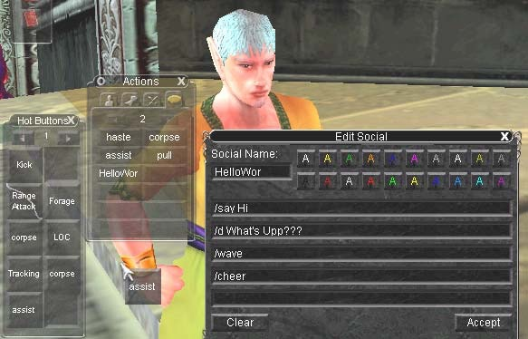Deep customizability: We mentioned the vast possibilities on modifying interfaces but how they actually work? Let’s take a look into3 interesting methodologies applied in these games. First the Anything-goes interface malleability; game interfaces are like clay and they can be modified if the designer allows it, this allows users to modify their UI to deal with different tasks depending on the situation. This malleability is conceived modifying the interface layout or the mapping from controls to functions. Everquest has a technique which allow redesign, move and play with their UI and even export it providing high usability for particular scenarios and change from one UI configuration to another at any minute. Users can change or add functions for a particular control or key to be executed (often called key binding), remapping default constructs. In addition to alterations of the UI, games reduce the threshold needed to extend their UI capabilities, users are allowed to create macros (a serial command to minimize and facilitate execution of a particular duty that can be implemented by pressing a single designated key), import toolkits and complete programs to perform desired routines. In EverQuest users find “button blanks” that act as containers for macros and command extensions.

*Screenshot from Learning from Games: HCI Design Innovations in Entertainment Software (Brown, B., Dyck, J., Gutwin, C., Pinelle, D.) Everquest’s macro builder (right), palettes of customized components (left) and a component stuck to the mouse pointer being dragged to a new location.*

With only a couple of mouse clicks the user can record the actions they want stored in the format of a new button, as soon this is finished the new task is deployed as part of the UI and ready to use or edit. As we mentioned in many games macros, scripts and layout distributions can be saved as regular XML files which in some cases allows use a customized UI setting from one game to another of similar features. Some game developers even encourage their users to create their own scenarios and mini games and modes just like happened years ago with programmer icefrog creating Dota out of a Warcraft III map.

Fluid system-human interaction: we talked about how immersive systems can help make the workflow more fluid. Games deliver messages in an unobtrusive way that does not require users to acknowledge, address or dismiss them. It is also known as Calm messaging and helps reducing user’s attention that in the end aid performance through the usage of animation, audio, speech and transient text. Some Apps would benefit greatly from the fluent workflow of calm messaging. Although, a certain number of elements must be considered, for example games are immersive Apps, different than productive or lightweight Apps. For instance, critical urgent tasks this wouldn’t be appropriate.

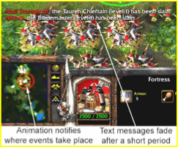*Screenshot from Learning from Games: HCI Design Innovations in Entertainment Software (Brown, B., Dyck, J., Gutwin, C., Pinelle, D.) Warcraft III Calm messaging. Text messages fade after a short time. Animated red concentric circles show the user where an event is taking place.*

In addition, some games automatically zoom, pan, rotate and perform another view options according to the instance for best display depending on the task to be done; these can also be customized. These are called attention-aware interface elements and context-aware view behaviours; an interesting technique that allow reduce areas of no interest prioritizing the workspace. The potential for applications to benefit from adopting some of these features is infinite. The situated learning from problem-solving contexts allow users learn a lot from computer games in terms of different approaches and methodologies to achieve a solution. Games provide information when it is needed, instead of all at once. Assessment and learning are tightly aligned through a constant feedback assessing player’s performance. Most games are highly engaging but at the same time addicting what opens another discussion.

Engagement is a highly important concept in HCI not only for designing but to implement diverse and adaptable interfaces. Usually described whenever the brain is challenged but after achievement, rewarded. Reward is essentially positive reinforcement of a model behaviour. Feedback, Novelty and Social Interaction are only some of the channels to express it. Everyone loves a great feedback, users feel at ease, comfortable and enjoy the experience. Several studies have showed how emotions may alter attention and memory performance.

**Conclusion**

Why does this research matter? Education and accessibility is key for mankind’s future. Better tools using a solid HCI approach will help more and more people to access the true elements behind the education and something magical will happen again: the new dawn of enlightenment, a new Martin Luther would have born. Undoubtedly, technology is going to be key in education in the coming years. The way we absorb things and its pace has changed tremendously over time due to the technological advances. Today students can access data in a variety of forms and methodologies according to their own learning styles. Studies have shown that attention spans have decreased on average students around the globe as we become more used, “slaves” expecting instantaneous access to any information. The “instant satisfaction” model present in today’s students might take a huge toll if not addressed properly and connected adequately into formal education.  In well-designed technology-enhanced learning environment learners would manipulate information and apply critical thinking to create new content based on it, as well as expressing and sharing their knowledge to peer-learners.  By working as a community, many fields such as HCI, Learning, the Video Game industry and others can hopefully make this a much more pleasant engaging a well-developed experience.

**References**

* Baecker, R.M., Grudin, J., Buxton, W.A.S., Greenberg, S. (1995). Readings in Human- Computer Interaction, 2nd edition. Morgan Kaufmann Publishers, San Francisco.
* Biggs, J. (1996). Enhancing teaching through constructive alignment. *Higher Education 32,* 347-364.
* Bruff, D. (2009). *Teaching with classroom response systems: Creating active learning environments*. San Francisco: Jossey-Bass.
* Carroll, J.M. (2003) (ed.): HCI Models, Theories, and Frameworks. The Morgan Kaufmann Series in Interactive Technologies. Morgan Kaufmann Publishers, San Mateo.
* Carrol, J. M. (2004) Beyond fun, interactions 11(5), pp 38-40.
* Chalmers, P.A. (2003). The role of cognitive theory in human–computer interface. *Computers in Human Behaviour, 19*, 593–607.
* Chickering, A. W., & Gamson, Z. F. (1987). Seven principles for good practice in undergraduate education. *American Association of Higher Education Bulletin*. *39* (7) pp.3-7.
* Cooper, S., Sahami, M. (2013) Education - Reflections on Stanford’s MOOCs. Communications of the ACM 56(2), 28–30.
* Dror, I. E. (2008). Technology enhanced learning: The good, the bad, and the ugly. *Pragmatics & Cognition, 16*(2), 215–223.
* Duncan, D. (2007). Clickers: A new teaching aid with exceptional promise. *Astronomy Education Review, 1*(5), 70-88.
* Dyck, J., Pinelle, D., Brown, B., & Gutwin, C. (2003). Learning from games: HCI design innovations in entertainment software. In *Proceedings of Graphics Interface 2003*.
* Goodyear, P., Retalis, S. (Eds.). (2010). *Technology-enhanced learning: Design patterns and pattern languages.* Rotterdam: Sense Publishers.
* Halkett, R., Schneider P., & Horne, M. (2010). *The learning society*. San Jose, CA: Cisco Systems. 12-14. Retrieved from: <https://www.cisco.com/c/dam/en_us/about/citizenship/socio-economic/docs/LearningSociety_WhitePaper.pdf>
* JISC. (2009). JISC Strategy 2010 - 2012. Retrieved from <https://www.webarchive.org.uk/wayback/archive/20140615094835/http://www.jisc.ac.uk/media/documents/publications/effectivepracticedigitalage.pdf>
* McCarthy, J. and Wright, P. (2004) Technology as Experience. MIT Press, Cambridge, MA.
* Nielsen, J. (1995) Heuristic Evaluation. In J. Nielsen and R. L. Mack (eds) Usability Inspection Methods, John Wiley & Sons Inc., New York.
* Nielsen, J. and Norman, D. (2014) The Definition of User Experience www.nngroup.com
* Nielsen (2014) www.useit.com
* Norman D. (2002) *The design of everyday things*. New York: Basic Books.
* Petty, G. (2018). *Teaching today: A practical guide* (5th edition). Cheltenham, UK retrieved from: <http://www.geoffpetty.com/activelearning.html>
* Pileggi, R., & O’Neill, P. N. (2008). Team-based learning using an audience response system: An innovative method of teaching diagnosis to undergraduate dental students. *Journal of Dental Education, 72*, 1182- 1188.
* Wegner, P. (1997) Why Interaction Is More Powerful Than Algorithms. Communications of the ACM 40(5), 81–91.